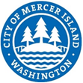
CITY OF MERCER ISLAND
9611 SE 36th Street • Mercer Island, WA 98040-3732
(206) 275-7605 • FAX (206) 275-7726
www.mercerisland.gov

May 11, 2021

MI Treehouse, LLC
Attn: Bill Summers
PO Box 261
Medina WA 98039
Via email

RE: CAO15-001/VAR18-002 Request for Information (5637 E Mercer Way, King County tax parcel #1924059312)

Dear Mr. Summers,
The City of Mercer Island Community Planning and Development Department has completed review of the updated application materials submitted February 1, 2021. There is one item on which additional information will be needed in order to complete review and schedule a public hearing: Details on grading within the slope wetland on site. Please clarify the nature of grading proposed, and if grading is required, please provide details on the on-site drainage system. Please review Attachment 1 for details.
The Planning Division’s processing of this application is on hold until this issue is resolved. Please do not hesitate to contact via the information below if you have any questions.
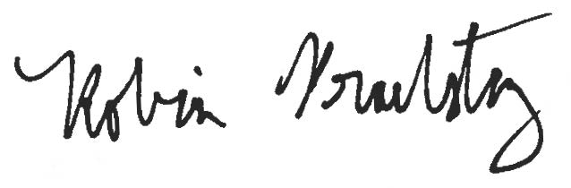
Sincerely,

Robin Proebsting, Senior Planner
City of Mercer Island Community Planning and Development
Robin.proebsting@mercerisland.gov
(206) 275-7717

Attachments:
- Memorandum prepared ESA, dated May 5, 2021
- Memorandum prepared by Wood Environment & Infrastructure Solutions dated May 4, 2021

